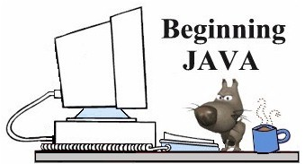
Using BreezyGUI
Message Boxes
A message box displays a message on the screen. When activated by a button, the message string appears in a separate box. A literal statement can be sent to the message box (as seen below) or a variable may be sent to the message box.
messageBox ("I love Java!!!");
To close the box, click the OK button
(or the x in the upper right corner of the window).
The message box can accept a String, double or integer as a parameter.
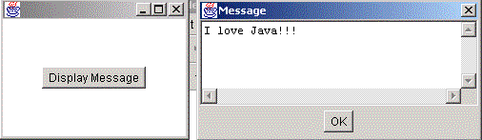
// Example of message box
import java.io.*;
import java.awt.*;
import BreezyGUI.*;
public class Box extends GBFrame
{
Button displayButton = addButton("Display Message",4,1,2,1);
public void buttonClicked (Button buttonObj)
{
String outputstring = "I love Java!!!"; // build an output string
messageBox(outputstring); // send the output string to the box
}
public static void main(String[] args)
{
Frame frm=new Box( );
frm.setSize(200,150);
frm.setVisible(true);
}
}
To print a money amount in a message box, use DecimalFormat (don't forget import java.text.*;)
//display calculations to look like a true money amount
DecimalFormat money = new DecimalFormat ("0.00");
outputString ="Your profit will be: $"+ money.format(profit) + ".";
messageBox(outputString);

